**Send Emails in Python with Gmail**

Send emails in a few lines of code

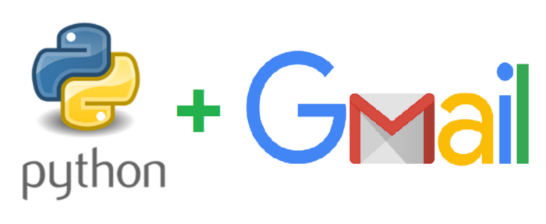

This post will explain how to set up an app password in Google account and use Python to send emails in a few lines of code for automatic reporting, test automation or CI/CD failure notification etc.

**Google Account Setup**

To use a Gmail account to send emails with a third party app, e.g. Python script, in this case, we need to set up an app password. For security reasons, the normal Gmail password is restricted to web login only. And as of 2020 even you turn on the [‘Less Secure App Access’](https://support.google.com/accounts/answer/6010255?hl=en) option in your google account, which is mentioned in some other posts, you won’t be able to log in to your Gmail account with the normal password in a Python script.

First, you need to enable 2-Step Verification. Just go to your Google Account > Security > Signing in to Google, and select 2-Step Verification and follow the instruction.

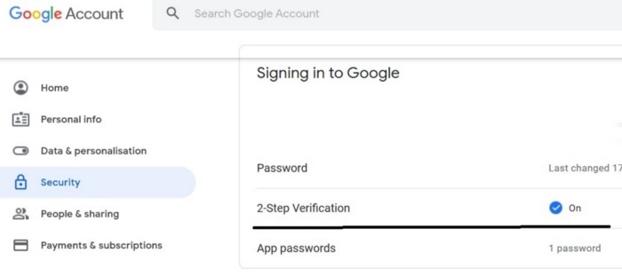

Enable 2-Step Verification

Next, create an app password. Just select ‘App passwords’ under ‘2-Step Verification’ and you will see a window as follows. Select ‘Other’ in the ‘Select app’ dropdown.

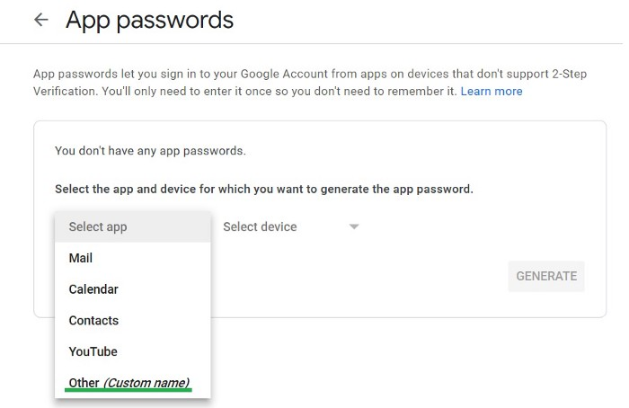

App password / Step 1

And enter a name, e.g. Python, and click ‘GENERATE’. Note this name has no link to the Python script and it could be anything.

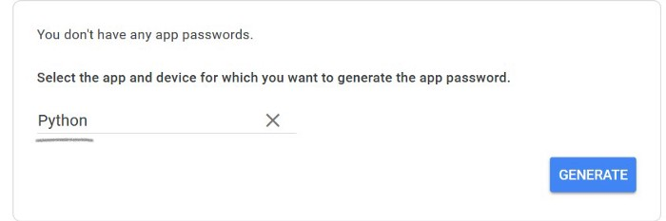

App password / Step 2

Then you will get a new app password. Copy and save the 16-character password without space, e.g. xnwbjmgvjeeevlgc, to use in your Python script.

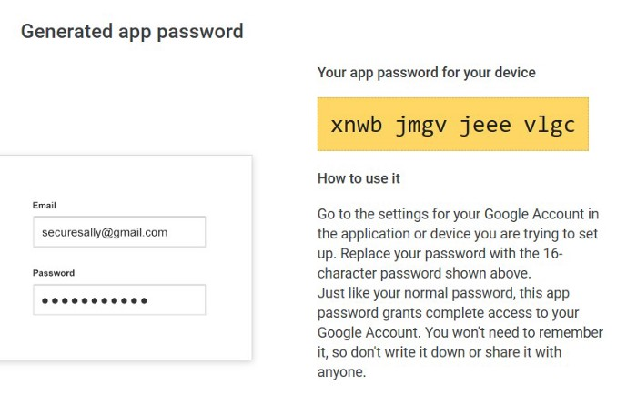

App password / Step 3

**Send Emails with yagmail**

[yagmail](https://github.com/kootenpv/yagmail) is a wrapper of Python standard library smtplib, which makes sending emails very easy.

To install yagmail in Python, simply run pip install yagmail.

Below is a sample script sending an email with two attachments.

The code is so simple and self-explained, so it barely needs any explanation. Apart from your Gmail username and app password, you just define to, subject and content just like writing an email from web Gmail. The content is a list, and the first element is the body text part and the rest are attachments. In this example, we attach ‘pytest.ini’ and ‘test.png’ from the same folder where the script resides.

To run this script, simply run python send_gmail_by_yagmail.py in any platform, Windows, Linux or MacOS. And you will get an email in the recipient account as follows.

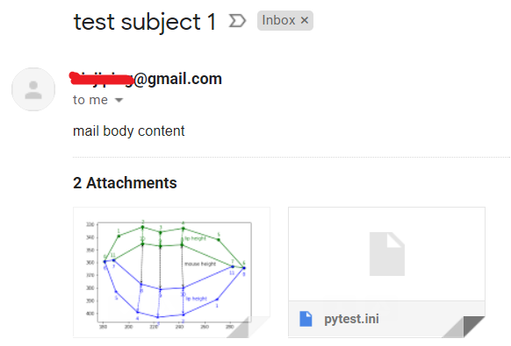

Sample Email

To send a group of recipients, simply change ‘to’ to a list.

to = [‘user1@gmail.com’, ‘user2@yahoo.com’]

Note that yagmail uses gmail SMTP server by default, and you can explicitly define the SMTP server and port.

host = 'smtp.gmail.com'  
port = 465  
with yagmail.SMTP(user, password, host, port) as yag: